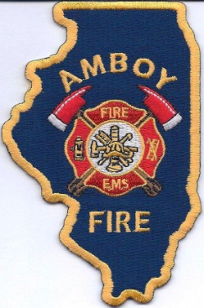
AMBOY FIRE DEPARTMENT
25 N. East Ave.
P.O. Box 165
Amboy, IL 61310
Phone (815) 857-2325 * Fax (815) 857-2066

Chief Jeff Bryant Sr.

Lt. Tim Klett, Retired NYFD Presents
Date: November 6th, 2021 (8am-5pm)
Hoarders Fires
This program is designed to challenge, both Engine and truck companies when
dealing with a hoarding situation under fire conditions. The Truck company will be
placed in a scenario in which they will have remove an unconscious victim
through moderate to heavy hoarding under a heavy smoke and high heat condition.
The engines companies will have to advance and flow an 1 ¾ hand line through
extreme hoarding conditions under a heavy smoke and high heat condition while
clearing a path for the hose lines advance. All attending students will be placed
through both the engine and truck evolution. This program will push each student
to their limits of both stamina and frustration, it is designed to be an extremely
challenging course so that when fire fighters are faced with true hoarding
conditions they can accomplish all their assigned tasks with a better understanding
on how to achieve them.

Register before September 15th
3 members for $200
After September 16th,2021-Cost: $100 per person
Location: Amboy Fire Station
How to Enroll: email: jbryant9962@gmail.com

