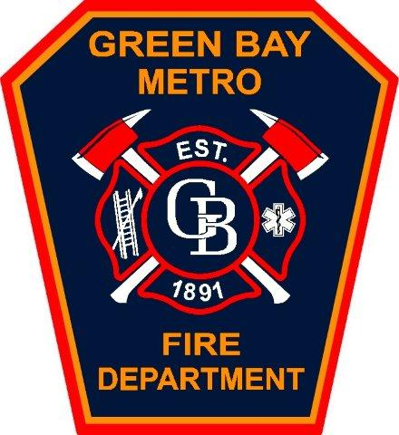
FIRE CHIEF
GREEN BAY METRO FIRE DEPARTMENT

The City of Green Bay is seeking an experienced fire service administrator with exceptional interpersonal skills and progressive management experience to serve as its Fire Chief. The successful candidate will possess a proven track record of innovative initiatives that have resulted in operational efficiencies. The Fire Chief has overall direction of fire prevention, fire suppression, and emergency medical services (EMS).
The City of Green Bay is a thriving city; it is the third largest city in the state of Wisconsin, with a population of approximately 107,000 and home to the Green Bay Packers. The Green Bay Metro Fire Department services the City of Green Bay and the neighboring villages of Allouez and Bellevue. The Fire Department has approximately 220 employees, 8 fire stations, and an operating budget of $21.7 million. In 2025, the department responded to over 18,500 calls for service, including approximately 12,000 emergency medical calls.
Strong strategic leadership and communication skills are required, along with labor relations, project management and budgetary experience. The successful candidate should be able to demonstrate a history of successful partnerships with other municipal and fire service agencies, promoting cooperation and increased efficiency.

Qualified candidates will possess the following qualifications:
- Bachelor’s Degree in Fire Science, Business Administration or Public Administration. A Master’s Degree is preferred.
- Seven years progressively responsible supervisory and managerial experience, including budgetary and union labor relations experience.
- Valid driver’s license and good driving record.
- Graduate of the Executive Fire Officer Program at the National Fire Academy is desired.
TO APPLY
TO APPLY
- Chief Fire Officer Designation (CFOD) is desired
- A combination of equivalent experience and/or education may be considered

Salary is commensurate with experience up to $147,971 plus excellent fringe benefits, including health, dental, life insurance and pension. The City of Green Bay is a leader in employee health and wellness with its Health/1265 program with a goal to engage all employees in their own health and well-being by providing insurance premiums incentives and other benefits.

We are committed to fostering a diverse and inclusive work environment. We invite candidates of all backgrounds and experiences to apply, knowing that unique perspectives enhance our service to the community.

Applications will be accepted until the position is filled.

Apply online at www.greenbaywi.gov/jobs; (920) 448-3147; EOE

