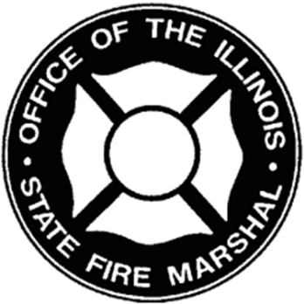 | Office of the State Fire Marshal  and the  Illinois Fire Chiefs  Educational & Research Foundation  CHIEF FIRE OFFICER  CERTIFICATION
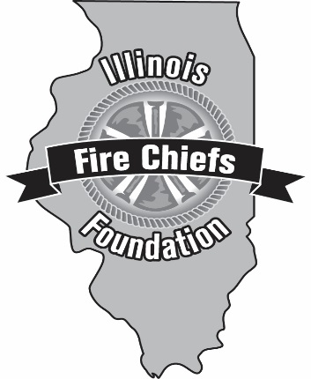

Chief Fire Officer Application

January 2022

Office of the State Fire Marshal
and the
Illinois Fire Chiefs
Educational & Research Foundation

WHY YOU SHOULD APPLY
The successful Chief Officer of any organization must possess diverse knowledge and skills not prevalent in the traditional aspects. However, there is a growing recognition of the critical role that education must play in building a quality organization. The Chief Fire Officer Certification program addresses those current issues and will provide the Chief Executive Officer with the tools needed to be a progressive leader.

This program replaces the Fire Officer III Program and meets the requirements for OFSM certification at the newly established Chief Fire Officer level. This program meets all the requirements at the N.F.P.A. Fire Officer III and IV level. The program is designed and intended for Command level officers and/or Administrators who have the responsibilities of supervising and administrating a Fire Department or Fire District. Officers preparing for a Chief level position are encouraged to apply.

The majority of the program is on-line with only one classroom session for each class. The program is divided into 12 modules containing one class each and three independent study projects that require a written research paper.

COURSE TOPICS
Leadership | Legal Issues
Communications | Strategic Planning
Personal and Professional Development | Emergency Management  Code Enforcement and Public Education
Working in the Community  Intergovernmental Relations  Human Resources | Budget and Finance Issues  Life Safety Initiatives

For students outside of the 150 mile radius of NIPSTA the course is available on-line. This allows participation in the classroom sessions from any computer with on-line access and a web cam.

WHO SHOULD ATTEND
This program is designed and intended for Chief Officers and/or Administrators who have the responsibilities of supervising and administrating a Fire Department or Fire District. However, because of the diverse organizational structures and administrative responsibilities that an Officer may have, each application packet will be reviewed for possible admission into the program. The sponsoring department’s Fire Chief and or designee will be required to approve the student’s entrance into the program & acknowledge the commitment from the department and that the student for this course will complete all assignments and attendance requirements associated with the Program.

O.S.F.M. CERTIFICATION REQUIREMENTS
All candidates who complete all the prerequisites will meet all the educational requirements for Chief Fire Officer Certification. Some candidates may receive Provisional Chief Fire Officer depending on job responsibilities and experience as identified below.

CHIEF FIRE OFFICER CERTIFICATION
- Fire Officer II or III Certified.
- Document Administrative Fire Service experience.
- Must submit current Job Description.
- Must submit official Organizational Chart.
- Must submit the Work Accomplishment Document.

ILLINOIS FIRE CHIEFS' FOUNDATION REQUIREMENTS
The program begins each year in January and concludes in December. Once the program is completed an end of course certificate will be given upon successful completion. Make up sessions may be available on a very limited basis depending on content missed.

COURSE FEE
For those candidates enrolled in the Chief Fire Officer program the tuition is $3,550.00. This fee includes all educational materials, lunch and administrative expenses. This fee includes all educational materials and administrative expenses.

CORRELATION STUDY
If the applicant currently holds a Bachelor's or Master's degree in a fire service management related area, public administration or has completed the Executive Fire Officer form the National Fire Academy a correlation study may eliminate the independent study port of the program.

SCHOLARSHIPS
A limited number of 50% tuition scholarships are available on a limited basis. Preference is given to applicants not eligible to receive tuition reimbursement.

For questions about the program please contact:
Chief James Dominik
Phone number: 847-567-2601
Email address: jdominik@illinoisfirechiefs.org

The completed application and supporting information must be sent to the Chief Fire Officer Registrar at the e-mail address listed below.
Dianna Wiessner
Phone number: 708-418-4349
Email address: dwiessner@illinoisfirechiefs.org

Once the application is received, the applicant will be notified of his/her status.
We are making every effort to make the program as paperless as possible so please send all registration documents as a single PDF to the e-mail address above.

Illinois Fire Chiefs Association Educational & Research Foundation

Chief Fire Officer Application 2022

Name:

Title:

Driver’s License #:

E-Mail Address:

Home Address:

City, State, Zip:

Home Phone: |  | Cell Phone:
Department/District Name:

Address, City, State, Zip:

Dept. Phone: | Dept. Fax:

Fire Chief's Approval & Understanding of Department’s Commitment.

Fire Chiefs Name:
Fire Chiefs Signature:
Date:

Please indicate below what you are applying for:
- Complete Chief Fire Officer Program
- 50% Tuition Scholarship (for complete CFO program only)

The completed application must have the following items attached:
- Completed Application
- Applicant’s Resume (Must include date of FO II, degrees earned and job experience)
- Scholarship Application

