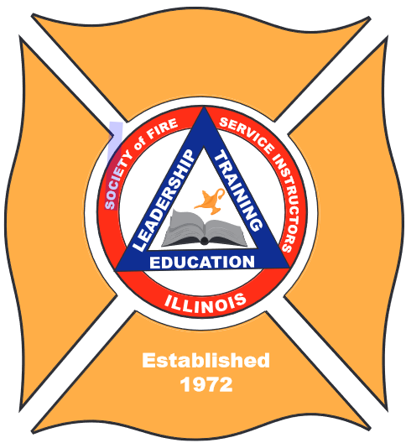

Illinois Society of Fire Service Instructors

51st Annual Instructor’s Conference 2023

September 20 – 22, 2023

**Training and Education into the Future**

**Where: Par-A-Dice Conference Center, East Peoria IL**

**Wednesday, September 20**

OSFM/IFSI Updates, recertification lecture, followed by Instructor of the Year Recognition and Dinner.

**Thursday, September 21**

Recertification lectures, exercises, and breakout sessions throughout the day. Casino Night is back with DJ and Karaoke. Breakfast and lunch included.

**Friday, September 22**

Final recertification sessions and after-action reviews until 11:30 PM. Breakfast is included.

**Cost: $275.00, register online at** [**https://ill-fireinstructors.org/**](https://ill-fireinstructors.org/)

**The registration page provides a link to the hotel for room reservations. (Payment and Reservations are the responsibility of the attendees)**

***Exercises and Training to Bring Back to YOUR Department for Recertification***