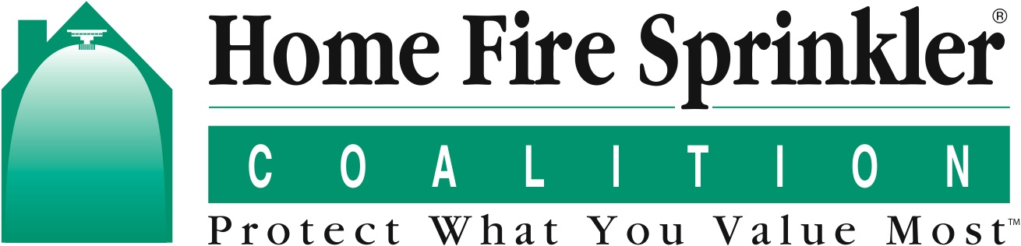

Contact: Peg Paul
(815) 592-9278

50 U.S. Fire Departments Will Receive $500
For Local Home Fire Sprinkler Education

The deadline to apply is March 6, 2020.

February 3, 2020, Frankfort, IL – As part of its ongoing nonprofit safety education mission, the Home Fire Sprinkler Coalition (HFSC) is inviting all U.S. fire departments to apply for new stipend awards that will increase local awareness of home fire sprinklers. With generous underwriting from State Farm, National Fire Protection Association (NFPA) and National Fire Sprinkler Association (NFSA), 50 qualifying departments will receive $500 to enhance their local outreach.

The stipends are being rolled out ahead of Home Fire Sprinkler Week, which will take place across North America May 17-23, 2020. Co-Sponsored by HFSC and the NFPA Fire Sprinkler Initiative, the week emphasizes the dangers of home fires to residents and firefighters and promotes the importance of building new homes with automatic fire sprinklers.

The stipends will help fire departments of any size or type conduct educational demonstrations. The funds can be used to build a portable, full-scale home fire sprinkler riser display, build or refurbish a side-by-side home fire sprinkler and flashover unit or produce an educational banner. HFSC has comprehensive online guidelines that describe materials, construction and outreach strategies to create these powerful and reusable teaching resources.

“With fire service activities concentrated on these important points during a single week each year, we are able to significantly boost interest and awareness among the public, the media and local officials,” says HFSC President Lorraine Carli, vice president of Outreach and Advocacy for NFPA. “This is essential because eight of 10 fire deaths in the U.S. occur in home fires.”

Although the number of reported fires has decreased over the past 40 years, you are more likely to die in a fire today than you were in 1980. “Today’s home fires burn hotter and faster yet loss can be significantly reduced with sprinklers,” Carli adds. “We could practically eliminated fire deaths in future years if every home had sprinklers.”

To qualify, applicants must be current members of the free Built for Life Fire Department Program (BFLFD), developed by HFSC in the 1990s to help the fire service improve local home fire sprinkler education. They will also be required to describe their plan to use and evaluate their awards. Join the BFLFD Program and apply for a stipend. The deadline to apply is March 6, 2020.

A similar stipend program is under way in Canada https://homefiresprinklercanada.ca/500-stipends-available-for-fire-and-sprinkler-burn-demonstrations/, with underwriting from HFSC’s Canadian partner The Co-Operators.

Now in its third year, Home Fire Sprinkler Week has become popular with fire departments in the US and Canada and HFSC anticipates widespread participation again in 2020. “The public education work the fire departments will do with these valuable stipends is essential and it will help make Home Fire Sprinkler Week 2020 an educational and motivational success,” Carli says. “We are appreciative of the strong support of the fire service, the HFSC Board of Directors, and our partners State Farm and The Co-Operators.”

Learn more about Home Fire Sprinkler Week {link} and follow HFSC activities on Facebook: http://www.facebook.com/HFSCorg
Instagram: https://www.instagram.com/homefiresprinklercoalition/
On Twitter: https://twitter.com/HFSCorg and in Canada https://twitter.com/HFSCinCanada

