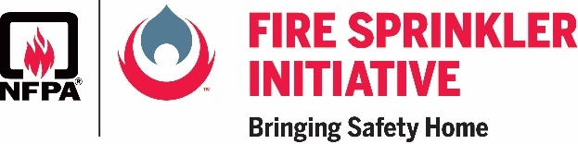 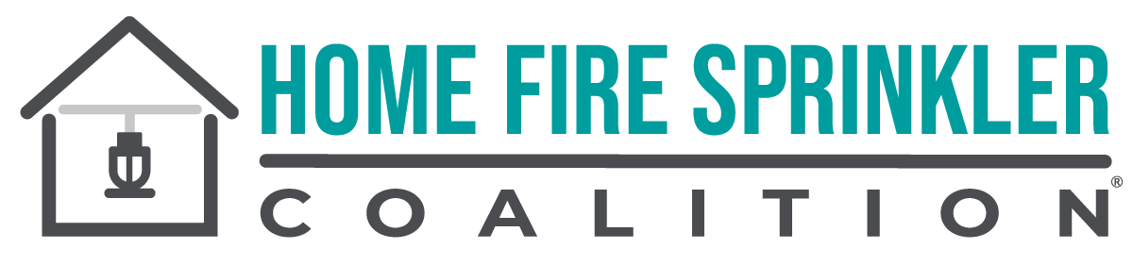

*Contact:* Peg Paul

815-592-9278

peg@ppacom.com

**Nominations now being accepted for NFPA, HFSC Bringing Safety Home Award**

**DEADLINE: April 7, 2023**

*March 3, 2023* – The National Fire Protection Association (NFPA) and the Home Fire Sprinkler Coalition (HFSC) are accepting nominations for their Bringing Safety Home Award, which recognizes outstanding efforts by a safety advocate who diligently promotes the importance of home fire sprinklers.

The Bringing Safety Home Award honors members of the fire service and other fire sprinkler advocates in North America who use HFSC educational material, NFPA data, and NFPA Fire Sprinkler Initiative resources to educate decision-makers on home fire sprinklers. These efforts are aimed at educating the public and policy makers to increase the use of home fire sprinklers in new homes. The award winner will receive a $1,000 grant to further fire sprinkler advocacy and educational efforts in their area. The winner will be announced during Home Fire Sprinkler Week May 14–20, 2023.

Use this [Bringing Safety Home Award online form](https://docs.google.com/forms/d/e/1FAIpQLScPJxYKdyYOZFy5cQNr87Iyrv6zDzfLqyx7ixe_RvYZnV16eA/viewform) to nominate an advocate for the Bringing Safety Home Award.

# # #

**About the National Fire Protection Association (NFPA)** Founded in 1896, NFPA is a global self-funded nonprofit organization devoted to eliminating death, injury, property and economic loss due to fire, electrical and related hazards. The association delivers information and knowledge through more than 300 consensus codes and standards, research, training, education, outreach and advocacy; and by partnering with others who share an interest in furthering the NFPA mission. For more information, visit www.nfpa.org. All NFPA codes and standards can be viewed online for free at [www.nfpa.org/freeaccess](http://www.nfpa.org/freeaccess).

**About the Home Fire Sprinkler Coalition (HFSC)**

HFSC was formed in 1996 to inform the public about the life-saving value of sprinkler protection in one- and two-family homes. HFSC is a purely educational, nonprofit organization and the leading resource for independent, noncommercial information about home fire sprinklers. For more information about HFSC and home fire sprinklers, visit

[www.homefiresprinkler.org](http://www.homefiresprinkler.org).